DKMUN’25 J-UNEP STUDY GUIDE

Table of Contents
Table of Contents 2
Letter From the Secretary-General 2
Letter From the Under-Secretary-General 3
Introduction to the United Nations Environment Programme 4
Introduction to the Agenda Item 5
Some Key Words Related to the Agenda Item 6
What Materials Harm the Environment? And, How? 7
1. Metals, especially Heavy Metals 7
2. Plastics 9
3. Hazardous Chemicals 17
The Bio-Degredability of Plastics 18
Some Alternative Ideas for Delegates 20
1. Plastics 20
2. Heavy Metals and Chemicals 21
Questions that Delegates May Address 21
Bibliography 22

Letter From the Secretary-General
Dear Distinguished Delegates,

It is with great pleasure and profound anticipation that I welcome you to this year’s conference. Serving as the Secretary-General is both a privilege and a responsibility, one that allows me to witness the convergence of intellect, diplomacy, and youthful ambition within each of you.

Model United Nations is far more than a simulation; it is a stage where empathy meets eloquence, and where collaboration transcends competition. As you engage in rigorous debate and negotiation, I urge you to embrace not only the art of argument, but also the virtue of understanding.

Let this conference be a space where your voices resonate beyond the committee rooms, where every speech, resolution, and handshake reflects the essence of leadership and global citizenship.

With sincere admiration and best wishes for an inspiring experience,

Yağmur Hançer
Secretary General

Letter From the Under-Secretary-General
Most Esteemed Delegates,

I would like to welcome you all to the Junior United Nations Environment Programme committee of Denizli Koleji Model United Nations Conference 2025. My name is Cansu Omurcalı and I will be serving as the Under-Secretary-General of this committee.
I have picked this agenda item because climate change is one of the biggest problems our world is facing nowadays. It is important to raise awareness starting from a young group of people to change the future generation. I hope that you can learn new information here in this committee and perhaps live one of the best experiences of your life. Model United Nations conferences are by far the most important type of conference you can join throughout your middle and high school years. My very first experience was also in a junior conference about a similar topic, so this committee is quite emotional for me, and I have to say, ever since my first experience, MUNs now play a big role in my life. I hope they become a great part of your life as well.
Please read this guide thoroughly and gather information about your country's stance on this topic before coming to the conference. I hope to see you all on October 17-18-19. If you have any questions, do not hesitate to contact me via Whatsapp or my email.
Best Regards,
Cansu Omurcalı

e-mail: omurcalicansuu@gmail.com

Introduction to the United Nations Environment Programme
The United Nations Environment Programme (UNEP) was founded by Mautrice Strong, in Stockholm on the 5th of June, 1972. The Programme was established to coordinate environmental initiatives within the United Nations. The rising temperatures, extinction of many species and natural disasters caused by climate change had raised the need for an international action to be taken, and that action was taken by establishing UNEP. Since its foundation, UNEP has worked on helping Member States’ governments to take action against climate change by playing a role as a negotiator in climate related treaties. The Environment Programme also releases publications and statistics on recent data about climate change, the management of marine and terrestrial ecosystems, and green economic development. UNEP aims to help the world meet the 17 Sustainable Development Goals to ensure a more sustainable world for both humans and other living creatures.

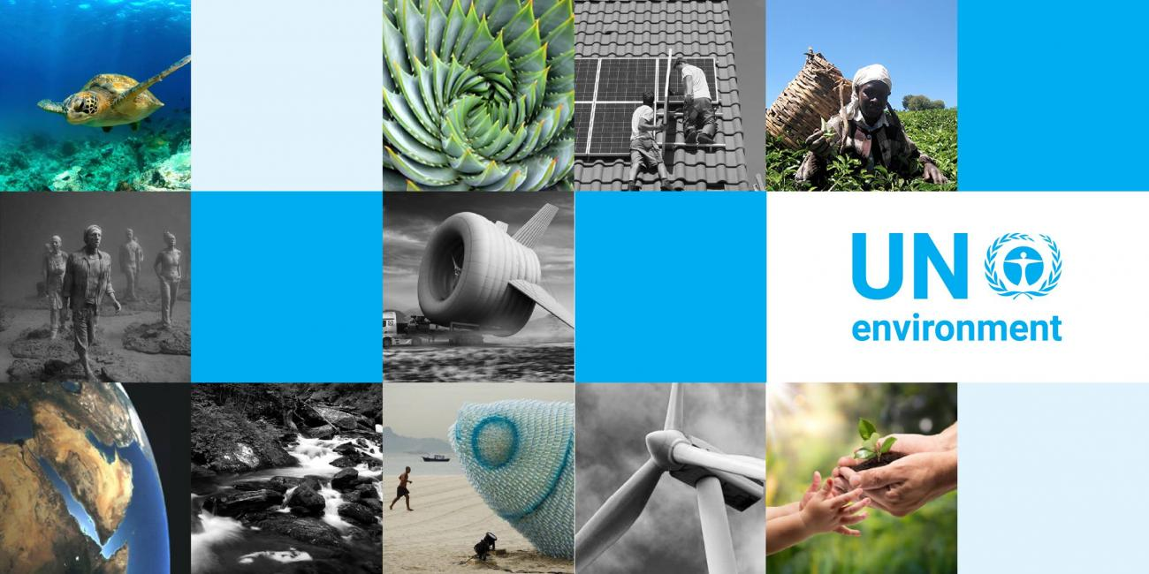

Introduction to the Agenda Item
The agenda item of our committee is “Finding alternatives to daily used materials that are harmful for the environment”, which means our goal for this committee is to find alternatives to materials that harm the planet in various kinds of ways, such as by being non-biodegradable and by having a non-environmental friendly production process. Due to the population increase, the demand for almost everything has risen as well. From food to technology and from clothes to sheltering, in every corner of the world something is always being produced and sold. To catch up with the high demand, production must be fast and cheap. Therefore, in the 1700s humanity switched from handicraft to factory production, which was way faster and cheaper. Since the Industrial Revolution, not just the way we produce things have changed but also the demand for raw materials has risen and the materials we use in the process of production have developed. For instance, the first industries that were transformed by innovations in the Industrial Revolution were related to the production of iron, coal, cotton and wool. Inventions and new practices in one industry tended to affect others. For example, the development of coal-powered steam engines led to an increased demand for coal.

Later on, in the 1900s plastic was invented and with that this material started to be used in packaging, automobiles, furniture, toys and almost in every field of our lives. The fact that it is low weight, durable, flexible, not too toxic and has a low-cost production makes it one of the most used materials today. However, plastics are produced from natural gas and petroleum, which are considered as fossil fuels and are not renewable, and they are non-biodegradable, which means that they take ages to dissolve when thrown out into the environment.
To summarize, we will firstly debate upon the negative effects of the materials that pollute the environment and endanger our planet, and then we will focus on finding alternatives to these materials, or try to find ways to lower their negative effects on our planet and the living creatures. So let’s start by learning what a plastic is, and how it is produced.

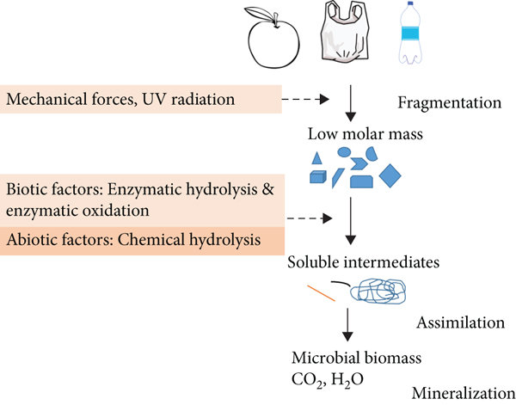
Some Key Words Related to the Agenda Item
Biodegradable: It means that a material can be broken down in the nature. For a product to be called biodegradable, most of it must break down within a short time. This “short time” standard changes from institution to institution. Some biodegradable products also turn into compost, which can be used to enrich soil. Tiny organisms like bacteria and fungi help in this process. Over time, the material turns into water, carbon dioxide, and organic matter. This biodegradation process happens without harming the environment.

Bioaccumulation: Bioaccumulation is characterized as the net accumulation of all contaminant sources in or on an organism, including water, air, and diet. Bioaccumulation is distinguished as an increase in the concentration of pollutants in aquatic organisms after absorption from the ambient environment. Relative to the environment, bioaccumulation defines the accumulation and enrichment of toxins in organisms.

Renewable: This term is usually used to describe a resource that is replenished faster than it is used. Renewable energy is the kind of energy that is renewed over time naturally. Solar energy, wind energy, geothermal energy and biomass energy can be counted as renewable energy sources.

What Materials Harm the Environment? And, How?
Some materials that we use for fulfilling our daily needs are harmful for the environment in many kinds of ways. For instance, plastic is resistant to many natural degradation processes and they take centuries to decompose in the soil. But being non-biodegradable is not the only way plastics affect the ecosystem in a negative way, they also pollute our oceans, aggravate the food chain and much more. Let us clarify the harmful materials and in which ways they harm the Earth.

Metals, especially Heavy Metals
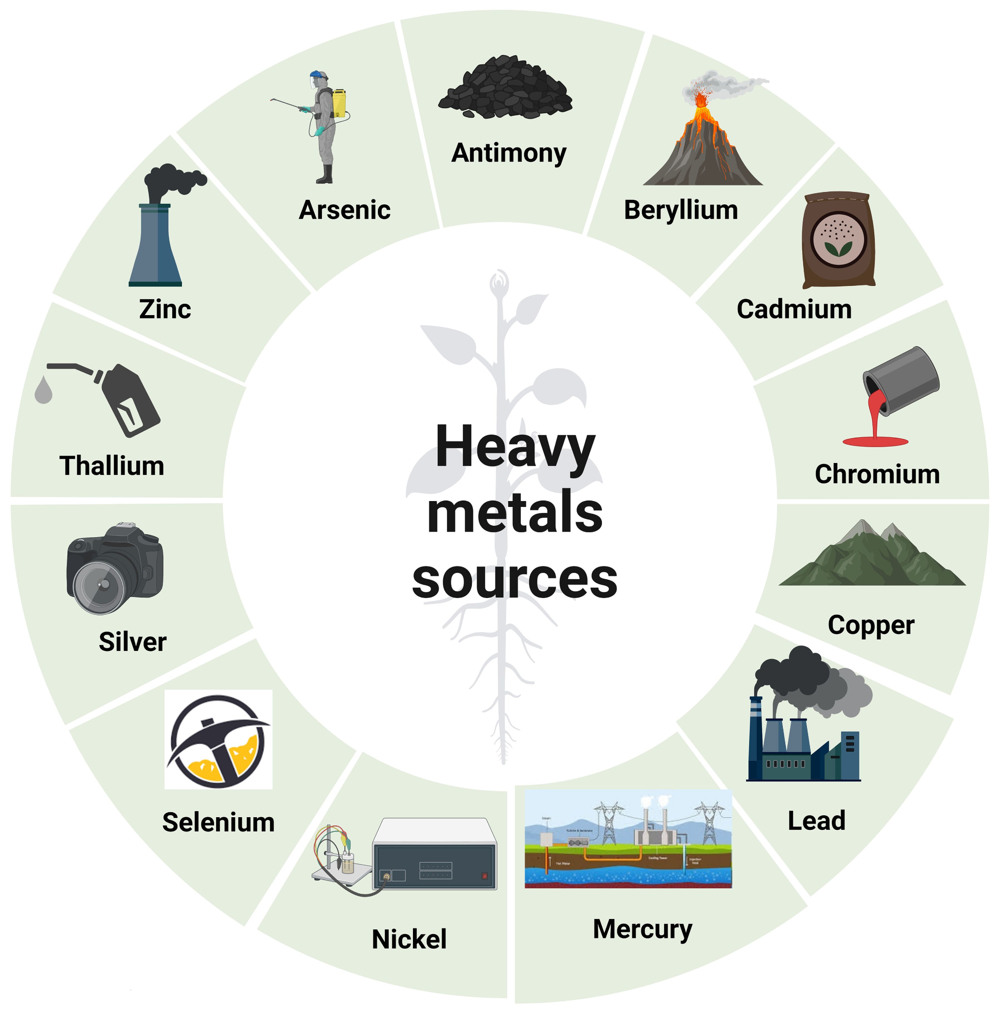
Because of their chronic toxicity, non-biodegradability, and environmental bioaccumulation, heavy metals are incredibly harmful environmental pollutants. Heavy metals can be transferred and biomagnified via food chains and seriously threaten human health. According to certain studies, the accumulation of heavy metals in soil may also result in a drop-in soil quality, a decrease in soil fertility and agricultural production. Not only life living on the soil is being threatened by heavy metals, but also marine life. Most metals pollute seas, oceans, rivers and lakes because they are found in waste waters produced by factories and mines. Heavy metals might enter fish through different routes, including dietary intakes and the incorporation of sediment particles. Many invertebrates are important food sources for fish and other aquatic species, and they provide a practical route for lead, copper, zinc, and cadmium absorption. Therefore heavy metals have the chance of entering the bodies of animals who eat fish as well. The bioaccumulation patterns of heavy metals, such as mercury (Hg), arsenic (As), Nickel (Ni), cobalt (Co), copper (Cu), cadmium (Cd), and chromium (Cr), have a significant influence on the lives of most organisms. Metals are classified into three groups. The first group includes metals such as mercury, cadmium, and lead, which are toxic at minimum concentrations. The second group of metals is less dangerous (bismuth, indium, arsenic, thallium, and antimony), and the third category includes essential metals such as zinc, cobalt, copper, iron, and selenium, which are part of several chemical or biochemical processes in the body and are only toxic above a certain concentration.
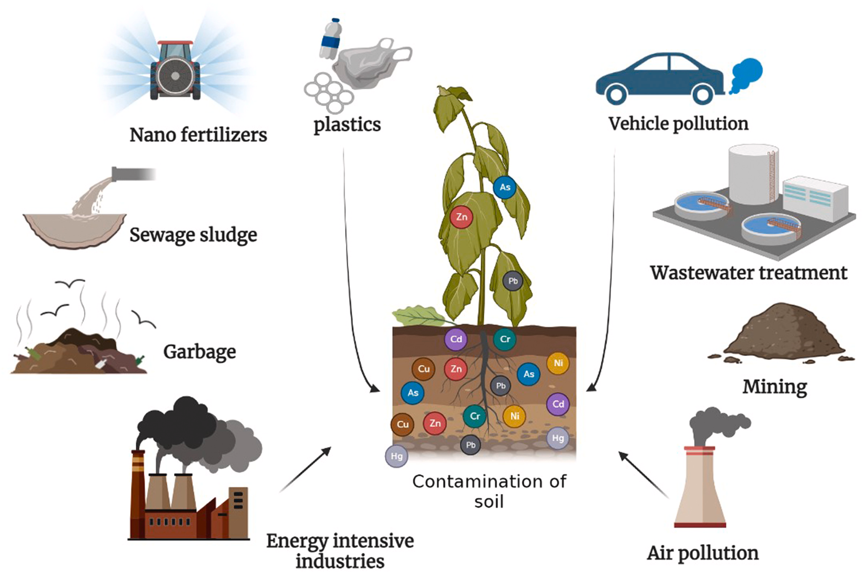
The major reasons for increased environmental toxicity owing to heavy metals are human factors. Natural sources of heavy metals include wind-blown soil debris, forest fires, volcanic eruptions, biogenic processes, and marine salt. Anthropogenic causes of heavy metals contamination include mining operations, pesticides, fertilizers, and herbicides use, crop field irrigation with industrial and sewage water, industrial waste management, traffic pollution, aerosol cans, metallurgy and smelting. Let us go through the areas of use of some heavy metals;

Mercury (Hg): several industries, including drug manufacturing, paper, and pulp preservatives, the farming sector, chlorine and caustic soda industry, release mercury (Hg) into the atmosphere.

Cadmium (Cd): widely used in electroplating for a variety of applications, including batteries, pigments, textiles, and metal coatings.

Lead (Pb): combustion of fossil fuels, paints and pigments; application of lead in gasoline, fertilizers, solid waste, incineration of industrial waste, explosive, ceramics and dishware.

Nickel (Ni): industrial dust, electroplating, production of iron and steel, food processing industries, chemical industries, incineration of waste, fertilizers, industrial aerosols, mining and metallurgy, battery, and combustion of coal.
Zinc (Zn): metal waste, fertilizers, electroplating, plating iron and steel, galvanization, mining and metallurgy.

Arsenic (As): industrial dust and waste, smelting of gold, lead, mining, medicinal, textile, wastewater, metal hardening, pesticides, paints, production of steel and iron, phosphate fertilizers, combustion of fossil fuels

When we take a look at the areas that these metals are used in, we can say that they all are used in similar industries. Agriculture, such as to produce fertilizers and pesticides, textile, mining, paints, medicine and electronics are all very common among heavy metals. Even though they are cheap and efficient compared to their alternatives, they are extremely harmful for the environment as explained before in the guide, therefore we will be discussing solutions for this matter. You can find information about the alternatives for these materials further in the guide.

Plastics
A plastic is a type of synthetic or man-made polymer; similar in many ways to natural resins found in trees and other plants. Webster's Dictionary defines polymers as: any of various complex organic compounds produced by polymerization, capable of being molded, extruded, cast into various shapes and films, or drawn into filaments and then used as textile fibers. Oil and natural gas are the major raw materials used to manufacture plastics. The plastics production process often begins by treating components of crude oil or natural gas in a "cracking process". Through this process, small molecules called “hydrocarbon monomers” are produced such as ethylene and propylene. Further processing leads to different types of monomers. These monomers are then bonded chemically into chains called “polymers”. The different combinations of monomers yield plastics with a wide range of properties and characteristics.

Plastics are inexpensive, lightweight, strong, durable, corrosion-resistant materials, with high thermal and electrical insulation properties. The diversity of polymers and the versatility of their properties are used to make a vast array of products that bring medical and technological advances, energy savings and numerous other societal benefits. As a consequence, the production of plastics has increased substantially over the last 60 years from around 0.5 million tonnes in 1950 to over 260 million tonnes in 2010. In Europe alone the plastics industry had a turnover in excess of 300 million euros and employed 1.6 million people in 2010. Almost all aspects of daily life involve plastics, in transport, telecommunications, clothing, footwear and as packaging materials that facilitate the transport of a wide range of food, drink and other goods. There is considerable potential for new applications of plastics that will bring benefits in the future, for example as novel medical applications, in the generation of renewable energy and by reducing energy used in transport.

Plastics are mainly divided into two. One is called “thermoplastics” and the other type “thermosets”. Thermoplastics, typically can be easily recycled since they can be melted and reshaped into new products. The good news is that the majority of the plastic that is manufactured is classified as a thermoplastic (80%) which means that theoretically it can be re-used. Sadly, in practice this is not typically the case. All thermoplastics (apart from PVC – which damages machinery) can go through the pyrolysis process to recycle the material. Pyrolysis involves heating the material at 400 degrees with no oxygen to break it down back into original components.

However, this is not so easy for thermoset plastics since they retain their shape once they have initially been molded. These plastics cannot easily be melted and reshaped, so the recycling process for these types of plastics is more involved. Often this means grinding the thermoset materials into smaller fragments so that the smaller shards can then be reused as a component in the manufacturer of new materials. Let us take a look at the different types of plastics, which fields they are used in and their characteristics;

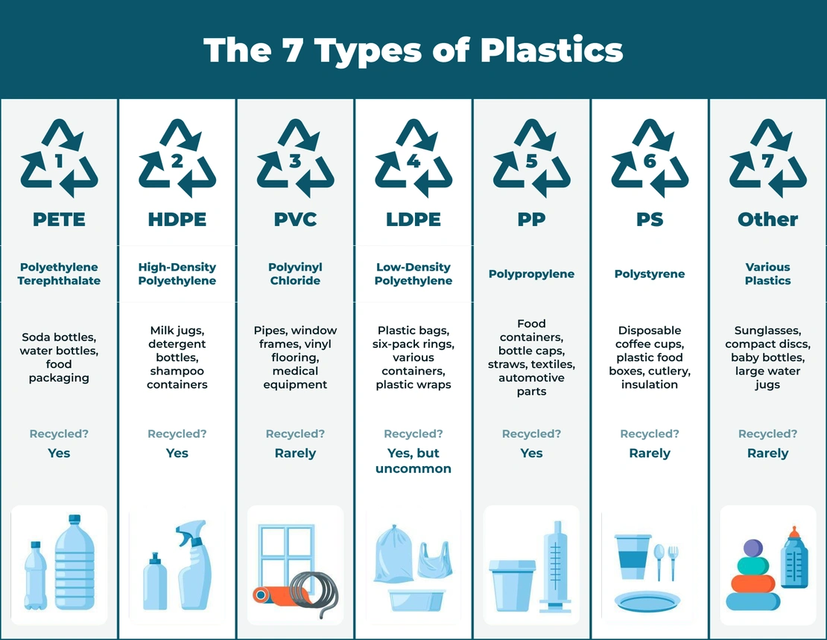

PET or PETE: It is clear, tough and has good gas and moisture barrier properties making it ideal for carbonated beverage applications and other food containers. The fact that it is resistant to high temperatures allows it to be used in heatable pre-prepared food trays and makes it an ideal heatable film. It is also used in fibers for clothing and carpets, bottles, food containers, strapping, and engineering plastics for precision-molded parts.

HDPE: It is used for many packaging applications because it provides excellent moisture barrier properties and chemical resistance. However, HDPE, like all types of polyethylene, is limited to those food packaging applications that do not require an oxygen or CO2 barrier. General uses of HDPE include injection-molded beverage cases, bread trays as well as films for grocery sacks and bottles for beverages and household chemicals.

PVC: It has excellent transparency, chemical resistance, long term stability, good weatherability and stable electrical properties. Vinyl products can be broadly divided into rigid and flexible materials. Rigid applications are concentrated in construction markets, which includes pipe and fittings, siding, rigid flooring and windows. Flexible vinyl is used in wire and cable sheathing, insulation, film and sheet, flexible floor coverings, synthetic leather products, coatings, blood bags, and medical tubing.

LDPE: It is predominantly used in film applications due to its toughness, flexibility and transparency. LDPE has a low melting point making it popular for use in applications where heat sealing is necessary. Typically, LDPE is used to manufacture flexible films such as those used for dry cleaned garment bags and produce bags. LDPE is also used to manufacture some flexible lids and bottles, and it is widely used in wire and cable applications for its stable electrical properties and processing characteristics.

PP: Polypropylene (PP) has excellent chemical resistance and is commonly used in packaging. It has a high melting point, making it ideal for hot fill liquids. Polypropylene is found in everything from flexible and rigid packaging to fibers for fabrics and carpets and large molded parts for automotive and consumer products. Like other plastics, polypropylene has excellent resistance to water and to salt and acid solutions that are destructive to metals. They are commonly used in ketchup bottles, yogurt containers, medicine bottles, pancake syrup bottles and automobile battery casings.

PS: Polystyrene is a versatile plastic that can be rigid or foamed. Its clarity allows it to be used when transparency is important, as in medical and food packaging, in laboratory ware, and in certain electronic uses. Expandable Polystyrene (EPS) is commonly extruded into sheets for thermoforming into trays for meats, fish and cheeses and into containers such as egg crates. EPS is also directly formed into cups and tubs for dry foods such as dehydrated soups. Both foamed sheet and molded tubs are used extensively in take-out restaurants for their lightweight, stiffness and excellent thermal insulation.

Other: There are many other plastics beyond the most common ones described above, for example nylon, ABS copolymers, polyurethanes, and polymethyl methacrylate.

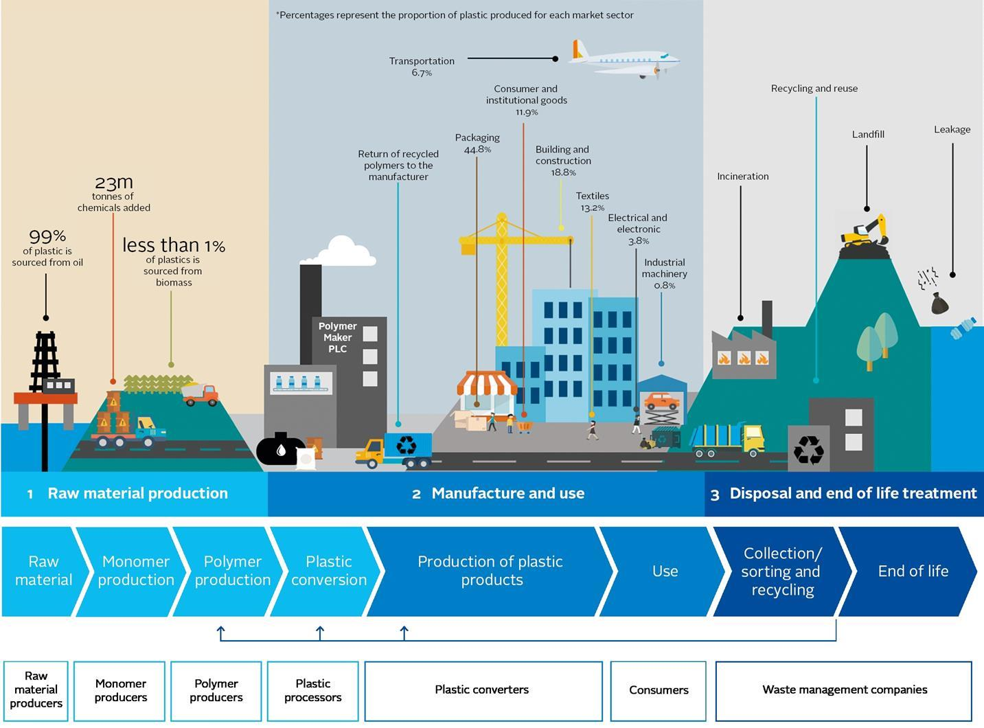
An infographic showing the life cycle of plastics

Every year, the world produces around 430 million tonnes of plastic, most of which soon becomes waste. This rising tide of plastic debris damages fragile ecosystems, stokes climate change and can result in human exposure to harmful chemicals. Some of the chemicals added to the structure of plastics are harmful and they may enter the environment or human bodies depending on the production practices, use and disposal. As a result, there is a risk of pollution to the soil, groundwater, the marine environment, or harm to human health. The production of plastic is also responsible for more than 3 per cent of global greenhouse gas emissions, contributing to the climate crisis. This all makes plastic pollution a driver of the triple planetary crisis of climate change, nature and biodiversity loss, and pollution and waste. The extraction of raw materials, their conversion into products, and use and disposal of a product are referred to as its life cycle. In the case of plastic, the story usually begins in the ground. For most plastics that are fossil fuel based, oil and gas are extracted from the earth and sent to refineries. There, they are transformed into plastic polymers, which are then moulded into products from water bottles and other single-use packaging material—including containers for food and beverage commodities—to fishing gear and products for use in agriculture or in transportation. After they have served their purpose, such products usually find their way to one of four places: a landfill (although often an uncontrolled dumpsite), an incinerator, a recycling or re-use centre and, most damagingly, the environment.

As mentioned in the chart about the types of plastics above, while some of these plastics are recyclable, some of them are not. For instance, PET is the most widely recycled plastic in the world. Nonetheless, despite being a relatively easy plastic to recycle, some countries are still struggling to reach decent recycling rates. India, Europe and South Korea all have rates higher than 50% but countries like the United States and China are yet to scale up those numbers. HDPE is accepted at most recycling centers in the world, as it is one of the easiest plastic polymers to recycle. Recycling companies will usually collect HDPE products and send them to large facilities to be processed. The last plastic-type that can be recycled is PP, also called polypropylene. While PP is easily among the most popular plastic packaging materials in the world, only around 1-3% is recycled in the US, which means most PP is headed for the landfill. In the United States it degrades slowly and takes around 20-30 years to completely decompose.

Out of the 7 types of plastic, 3 of them are not recyclable: PVC, PS and other types. LDPE is technically recyclable however, just because something can be recycled doesn’t mean it will be recycled. Plastic bags, which are made from LDPE, for example, tend to tangle in recycling machinery risking endangering the entire recycling process. In addition, LDPE is a very cheap and low-quality plastic making its recycling not really financially worthwhile. As a consequence, many municipalities won’t accept #4 plastic in curbside recycling bins. Despite these difficulties, when recycled, LDPE can be transformed into bin liners and packaging films.

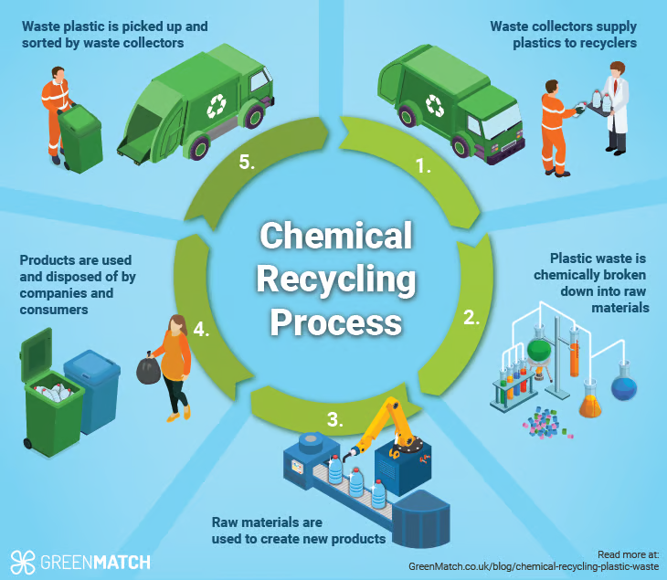

There is considerable concern about the adverse effects of these chemicals on wildlife and humans. In addition to the reliance on finite resources for plastic production, and concerns about additive effects of different chemicals, current patterns of usage are generating global waste management problems. A research made in 2009 shows that plastic wastes, including packaging, electrical equipment and plastics from end-of-life vehicles, are major components of both household and industrial wastes; our capacity for disposal of waste to landfill is finite and in some locations landfills are at, or are rapidly approaching, capacity. Therefore, it is urgent that we need to switch to other alternatives in the future.

The Great Pacific Garbage Patch is an example of the amount of plastic and other kinds of garbage in the oceans. The Great Pacific Garbage Patch is the largest of the five offshore plastic accumulation zones in the world’s oceans. It is located halfway between Hawaii and California in the Pacific Ocean. It is estimated that 1.15 to 2.41 million tonnes of plastic are entering the ocean each year from rivers. More than half of this plastic is less dense than the water, meaning that it will not sink once it encounters the sea.
The stronger, more buoyant plastics show resiliency in the marine environment, allowing them to be transported over extended distances. They persist at the sea surface as they make their way offshore, transported by converging currents and finally accumulating in the patch. Once these plastics enter the gyre, they are unlikely to leave the area until they degrade into smaller microplastics under the effects of sun, waves and marine life. As more and more plastics are discarded into the environment, microplastic concentration in the Great Pacific Garbage Patch will only continue to increase.
The GPGP covers an estimated surface area of 1.6 million square kilometers, an area three times the size of France. The mass of the plastic in the Great Pacific Garbage Patch (GPGP) was estimated to be approximately 100,000 tonnes, which is 4-16 times more than previous calculations.
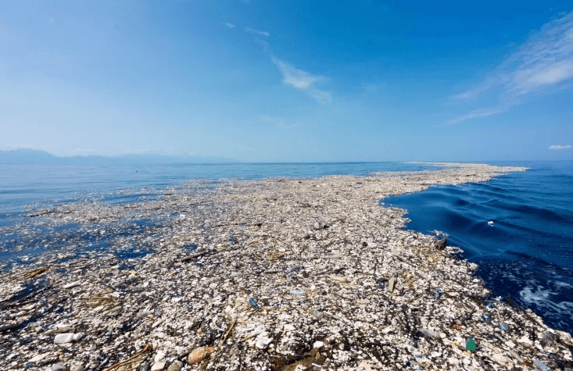
A photo of the Great Pacific Garbage Patch

Hazardous Chemicals
Thanks to the development of science in the past few decades, chemicals have had a huge role in both the lives of humans and other living creatures. Today we use chemicals in pesticides and herbicides for better and more efficient results in agriculture, azo dyes, formaldehyde, per- and polyfluoroalkyl substances (PFAS) for waterproofing in the textile industry, in house cleaning such as ammonia, chlorine bleach, phenols. Globally, chemical pollution has become a serious threat to sustainable development. Both humanity and ecosystems are suffering from the adverse effects of chemicals either through long-term exposure, low or sub-lethal concentrations of certain chemicals / mixtures of chemicals. The release of chemicals involves many steps in their life cycle. They begin from the extraction of raw
materials through production chains - transport and consumption - to final waste disposal. Their distribution sources mainly are through indoor environments, food and drinking water, soils, and water bodies (rivers , lakes
etc.). Certain long-lived chemicals such as persistent organic pollutants (POPs) and heavy metals are transported globally; reaching otherwise pristine environments such as rain forests, deep oceans or polar regions, and can
quickly pass along the food chain, bio-accumulating to cause toxic effects in humans and wildlife.

Today, in the 21st century, one of the major environmental challenges lies with the E-waste, which has also become a major threat to all the living
systems. It is found to be the fastest-growing waste stream in the world, with an estimate of 20–50 million tonnes per year. These E-wastes are of particular interest because they contain hazardous substances such as heavy metals including mercury and lead; Brominated flame retardants (BFRs) (endocrine-disrupting substances) and various strategic metals (gold, palladium and rare earth metals) that can be recycled and recovered.

The Bio-Degredability of Plastics
Most conventional plastics such as polyethylene, polypropylene, polystyrene, poly(vinyl chloride) and poly(ethylene terephthalate), are non-biodegradable, and their increasing accumulation in the environment has been a threat to the planet. To overcome all these problems, some steps have been undertaken. The first strategy involved production of plastics with a high degree of degradability.

The word ‘bio-plastic’ is used confusingly. However, bio-plastics usually consist of either biodegradable plastics (i.e., plastics produced from fossil materials) or bio-based plastics (i.e., plastics synthesized from biomass or renewable resources). The inter-relationship between biodegradable plastics and bio-based plastics is shown in the figure below. Polycaprolactone (PCL), and poly(butylene succinate) (PBS) are petroleum based, but they can be degraded by microorganisms. On the other hand, poly(hydroxybutyrate) (PHB), poly(lactide) (PLA) and starch blends are produced from biomass or renewable resources, and are thus biodegradable. Despite the fact that polyethylene (PE) and Nylon 11 (NY11) can be produced from biomass or renewable resources, they are non-biodegradable. Acetyl cellulose (AcC) is either biodegradable or non-biodegradable, depending on the degree of acetylation. AcC’s with a low acetylation can be degraded, while those with high substitution ratios are non-biodegradable.

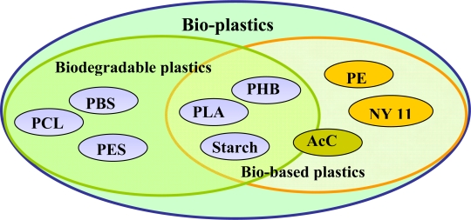
Bio-plastics comprised of biodegradable plastics and bio-based plastics

Biodegradable plastics are seen by many as a promising solution to this problem because they are environmentally-friendly. They can be derived from renewable feedstocks, thereby reducing greenhouse gas emissions. For instance, polyhydroxyalkanoates (PHA) and lactic acid (raw materials for PLA) can be produced by fermentative biotechnological processes using agricultural products and microorganisms. Biodegradable plastics offer a lot of advantages such as increased soil fertility, low accumulation of bulky plastic materials in the environment (which invariably will minimize injuries to wild animals), and reduction in the cost of waste management. Furthermore, biodegradable plastics can be recycled to useful metabolites (monomers and oligomers) by microorganisms and enzymes. A second strategy involves degradation of some petroleum-derived plastics by biological processes. A typical example can be seen in the case of some aliphatic polyesters such as PCL and PBS that can be degraded with enzymes and microorganisms. Studies have also shown that polycarbonates (particularly the aliphatic types) possess some degree of biodegradability. Thirdly, bold attempts are being made to recycle non-biodegradable plastics. For instance, polystyrene (used in making some disposable spoons, plates, cups and some packaging materials) can be recycled and used as filler for other plastics.

Some Alternative Ideas for Delegates

Plastics
Plastics are common in every field of our lives, but one of the most common forms of plastic is plastic bags. Since plastic bags are cheap, single-use and easy to carry around, they are a great option for carrying our stuff around. The world uses 5 trillion plastic bags a year. However most plastic bags are made from LDPE, which is a type of plastic that is recyclable but not really chosen since it is hard to recycle. It takes 1,000 years for a plastic bag to degrade in a landfill. Unfortunately, the bags don't break down completely but instead photo-degrade, becoming microplastics that absorb toxins and continue to pollute the environment. So instead of plastic bags, the usage of cloth bags and paper bags can be encouraged by encouraging governments to strengthen their laws. To ensure the biodegradability of bags, cloth bags can be made from natural textiles and not polyester or nylon, which are also types of fabrics that are made from plastics. (USE YOUR DKMUN’25 BAG WHEN GOING SHOPPING!!!!)

Another area that plastics are used in commonly is the textile industry. Nowadays many clothing brands produce clothes from synthetic fibers like polyester, nylon which are non-biodegradable and contribute to plastic waste accumulation in landfills and oceans, but also cheap and easy to produce at the same time. Limiting the environmental impact of synthetic fibres is achievable through a series of practical steps. These actions can significantly reduce the amount of synthetic fibre waste entering ecosystems. Simple practices include choosing clothing and textiles made from natural fibres, properly maintaining and repairing items to extend their lifespan, and adopting responsible disposal methods. Using laundry bags in washing machines can be helpful. Laundry bags are specialised bags used during washing to trap microfibres released from synthetic textiles, preventing them from entering the water system.

Tamarind is an evergreen tree that needs a dry climate to grow. Every part of tamarind is rich in nutritional value and is used as medicine. Its seeds are a good source of protein good for human health. Tamarind seed can be used in paint and cosmetic industries due to its acidic value. Polysaccharides present in tamarind seeds are biodegradable and biocompatible in nature and can be extracted from the endosperm of the seed.

Heavy Metals and Chemicals
Heavy metals and hazardous chemicals usually contaminate lakes, rivers, oceans and sewage systems causing water pollution and threatening marine life. A method called “biosorption” is a promising alternative for treating contaminated waters. Biosorption is a low-cost, easy-to-use, profitable, and efficient method of removing pollutants from water resources. Microorganisms are effective biosorbents, and their biosorption efficacy varies based on several aspects, such as ambient factors, sorbing materials, and metals to be removed. Microbial culture survival is also important. Basically, biosorption is a biological method of environmental control and can be an alternative to conventional contaminated water treatment facilities. It also offers several advantages over conventional treatment methods including cost effectiveness, efficiency, minimization of chemical/biological sludge, requirement of additional nutrients, and regeneration of biosorbent with possibility of metal recovery.

Questions that Delegates May Address
Here are a few questions to discuss in the committee during the three days. Please study these questions carefully, as these questions are what will be directing the debate.

- How do plastics, heavy metals, hazardous chemicals and other materials harm the environment?

- What are the negative effects of hazardous chemicals on human health?

- What is the difference between bioplastics and fossil fuel based plastics? Which one is less harmful to the environment?

- What are some alternatives to plastics that we use in daily life? How can we integrate these alternatives into daily use?

- How can we encourage governments and the private sector to increase the usage of bio-degradable materials?

- Should hazardous materials be restricted in countries? If so, how can we monitor these restrictions?

- How can we ensure proper waste management and recycling to decrease the dependence on producing more harmful materials?

- What alternatives can be used to decrease the negative effects of heavy metals on the ecosystem, especially marine life?

- What are some alternatives to pesticides, fertilizers and household cleaners that contain a huge amount of hazardous chemicals for the environment?

Bibliography
- https://www.unep.org/who-we-are/about-us#inspire
- https://www.globalbioenergy.org/biodegradable-meaning/
- R R, Remya & Julius, Angeline & Suman, T.Y. & Mohanavel, Vinayagam & Karthick, Alagar & .C, Pazhanimuthu & Samrot, Antony & Muhibbullah, Md. (2022). Role of Nanoparticles in Biodegradation and its Importance of Environmental and Biomedical Applications. Journal of Nanomaterials. 2022. 10.1155/2022/6090846.
- Amarjitsing P. Rajput, Madhur Kulkarni, Prashant L. Pingale, Muktika Tekade, Ashok K. Shakya, Rakesh Kumar Tekade,
Chapter 16 - Understanding the bioaccumulation of pharmaceuticals and personal care products,
- Madiha Zaynab, Rashid Al-Yahyai, Ayesha Ameen, Yasir Sharif, Liaqat Ali, Mahpara Fatima, Khalid Ali Khan, Shuangfei Li,
Health and environmental effects of heavy metals,
Journal of King Saud University - Science,
- Prodipto Bishnu Angon, Md. Shafiul Islam, Shreejana KC, Arpan Das, Nafisa Anjum, Amrit Poudel, Shaharia Akter Suchi,
Sources, effects and present perspectives of heavy metals contamination: Soil, plants and human food chain,
- Jessica Briffa, Emmanuel Sinagra, Renald Blundell,
Heavy metal pollution in the environment and their toxicological effects on humans,
- Thompson RC, Moore CJ, vom Saal FS, Swan SH. Plastics, the environment and human health: current consensus and future trends. Philos Trans R Soc Lond B Biol Sci. 2009 Jul 27;364(1526):2153-66. doi: 10.1098/rstb.2009.0053. PMID: 19528062; PMCID: PMC2873021.
- https://web.archive.org/web/20100317004747/http://www.americanchemistry.com/s_plastics/doc.asp?CID=1571&DID=5972
- A.K. Priya, Lalitha Gnanasekaran, Kingshuk Dutta, Saravanan Rajendran, Deepanraj Balakrishnan, Matias Soto-Moscoso,
Biosorption of heavy metals by microorganisms: Evaluation of different underlying mechanisms,
- https://www.plasticsforchange.org/blog/different-types-of-plastic
- Mohammad Asaduzzaman Chowdhury, Nayem Hossain, M.D. Badrudduza, Md. Masud Rana,
Development and characterization of natural sourced bioplastic for food packaging applications,
- https://www.biologicaldiversity.org/programs/population_and_sustainability/sustainability/plastic_bag_facts.html%23:~:text%3DThe%2520world%2520uses%25205%2520trillion%2520plastic%2520bags%2520a%2520year.%26text%3DAmericans%2520use%2520an%2520average%2520of,four%2520plastic%2520bags%2520per%2520year&sa=D&source=docs&ust=1759264769962112&usg=AOvVaw1AwKVqKTqtuCXThVy5Hy47
- Tokiwa Y, Calabia BP, Ugwu CU, Aiba S. Biodegradability of plastics. Int J Mol Sci. 2009 Aug 26;10(9):3722-3742. doi: 10.3390/ijms10093722. PMID: 19865515; PMCID: PMC2769161.

